**DAILY ONLINE ACTIVITIES SUMMARY**

|  |  |  |  |  |  |  |  |
| --- | --- | --- | --- | --- | --- | --- | --- |
| **Date:** | **28-06-2020** | | | | **Name:** | **B.A.SOHANKUMAR** | |
| **Sem & Sec** | **4TH SEM A** | | | | **USN:** | **4AL18CS013** | |
| **Online Test Summary** | | | | | | | |
| **Subject** | | **----** | | | | | |
| **Max. Marks** | | **----** | | **Score** | | **----** | |
| **Certification Course Summary** | | | | | | | |
| **Course** | **INTRODUCTION TO INFORMATION SECURITY** | | | | | | |
| **Certificate Provider** | | | **GLA** | **Duration** | | | **5.5 HOURS** |
| **Coding Challenges** | | | | | | | |
| **Problem Statement: Write a c program to convert temperature from Fahrenheit to Celsius and Celsius to Fahrenheit.** | | | | | | | |
| **Status:EXECUTED** | | | | | | | |
| **Uploaded the report in Github** | | | | **YES** | | | |
| **If yes Repository name** | | | | **LOCKDOWN CODING** | | | |
| **Uploaded the report in slack** | | | | **YES** | | | |

**CERTIFICATION COURSE DETAILS:**

Course: INTRODUCTION TO INFORMATION SECURITY

Completed modules today are Introduction to Software Security Lesson 2,Stanford Webinar - Hacked! Security Lessons from Big Name Breaches (Neil Daswani),Stanford Webinar - Hash, Hack, Code: Emerging Trends in Cyber Security (Dan Boneh) and successfully completed the course.

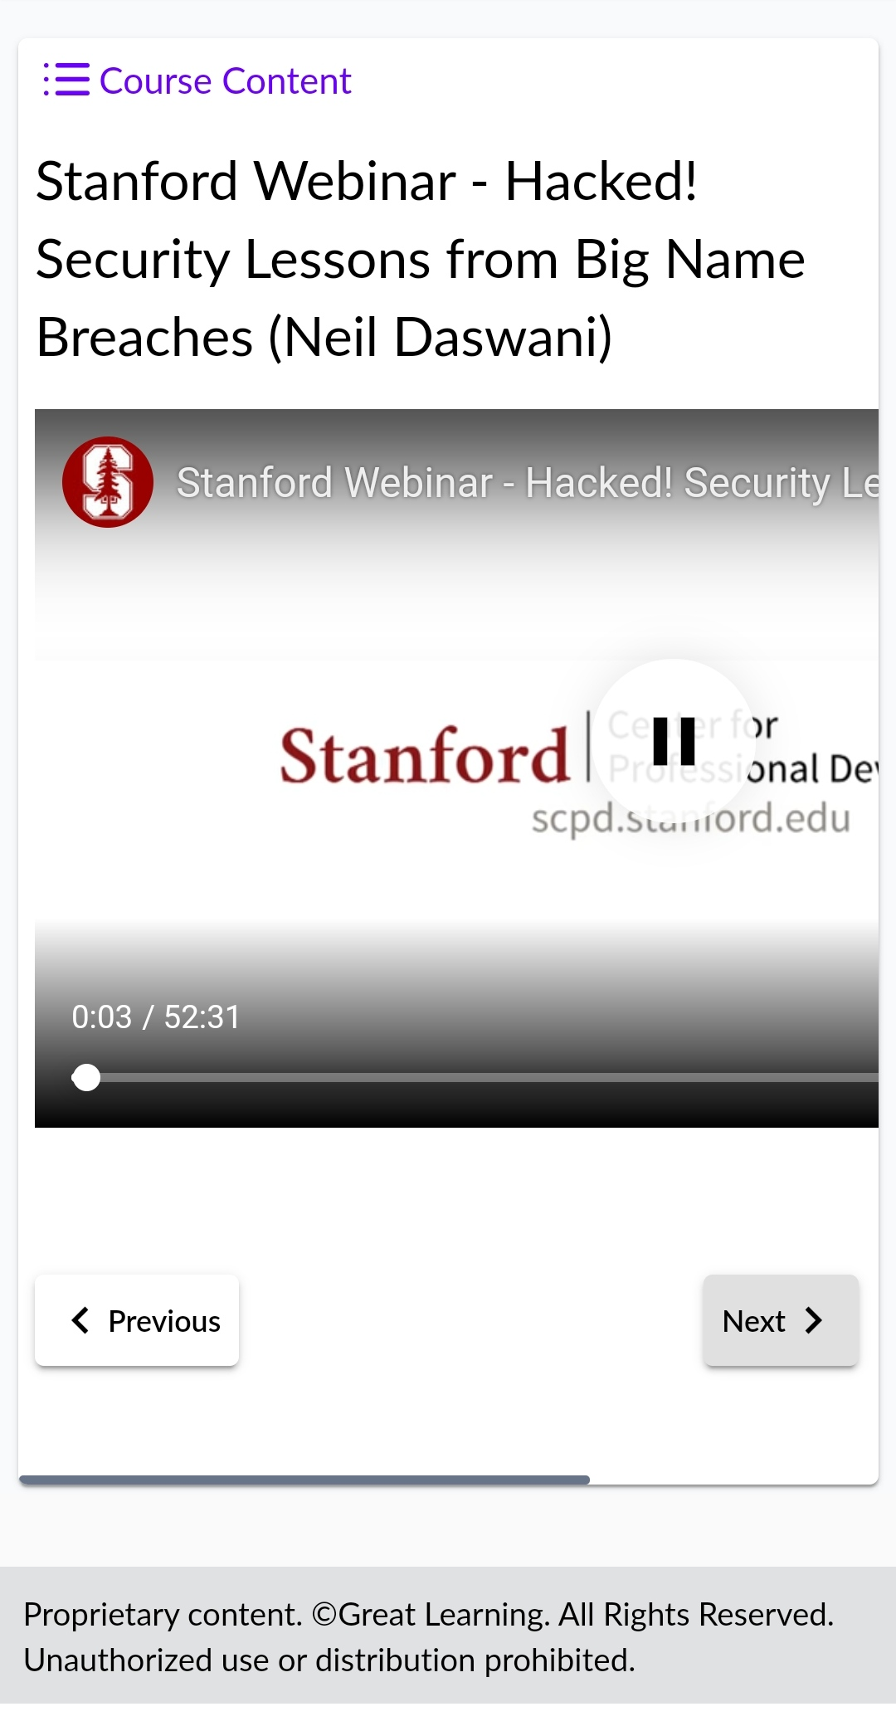 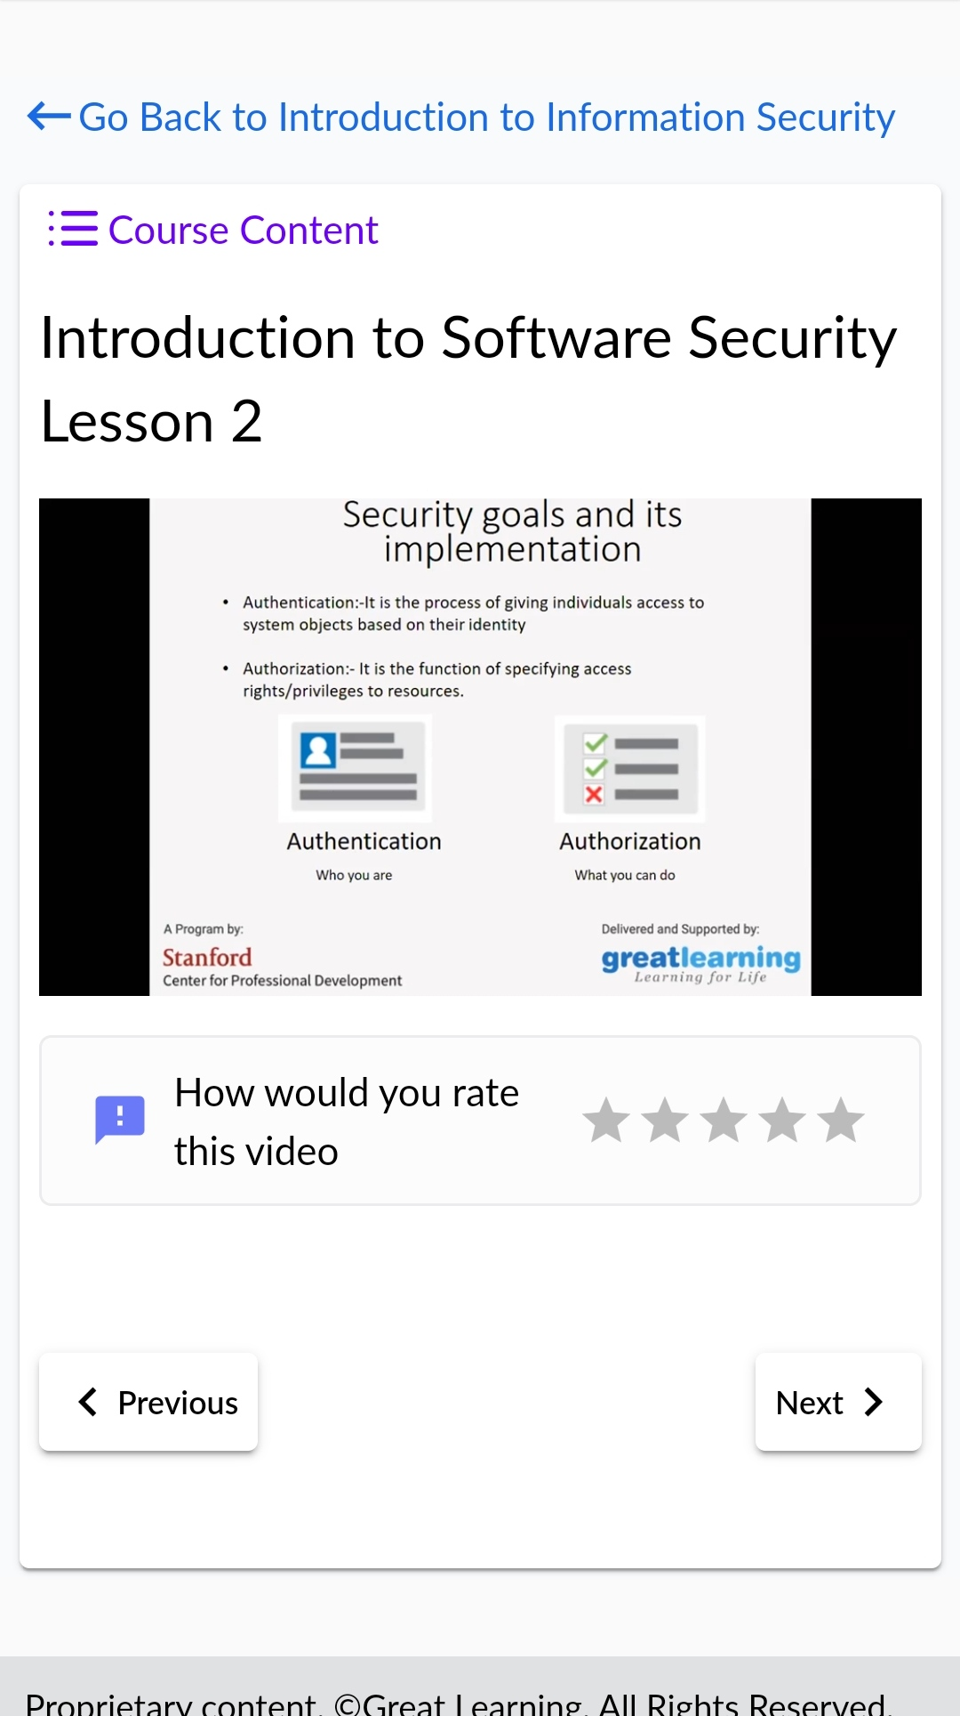

**CODING CHALLENGES DETAILS:**

1.C program to convert temperature from Fahrenheit to celsius and celsius to fahrenheit.

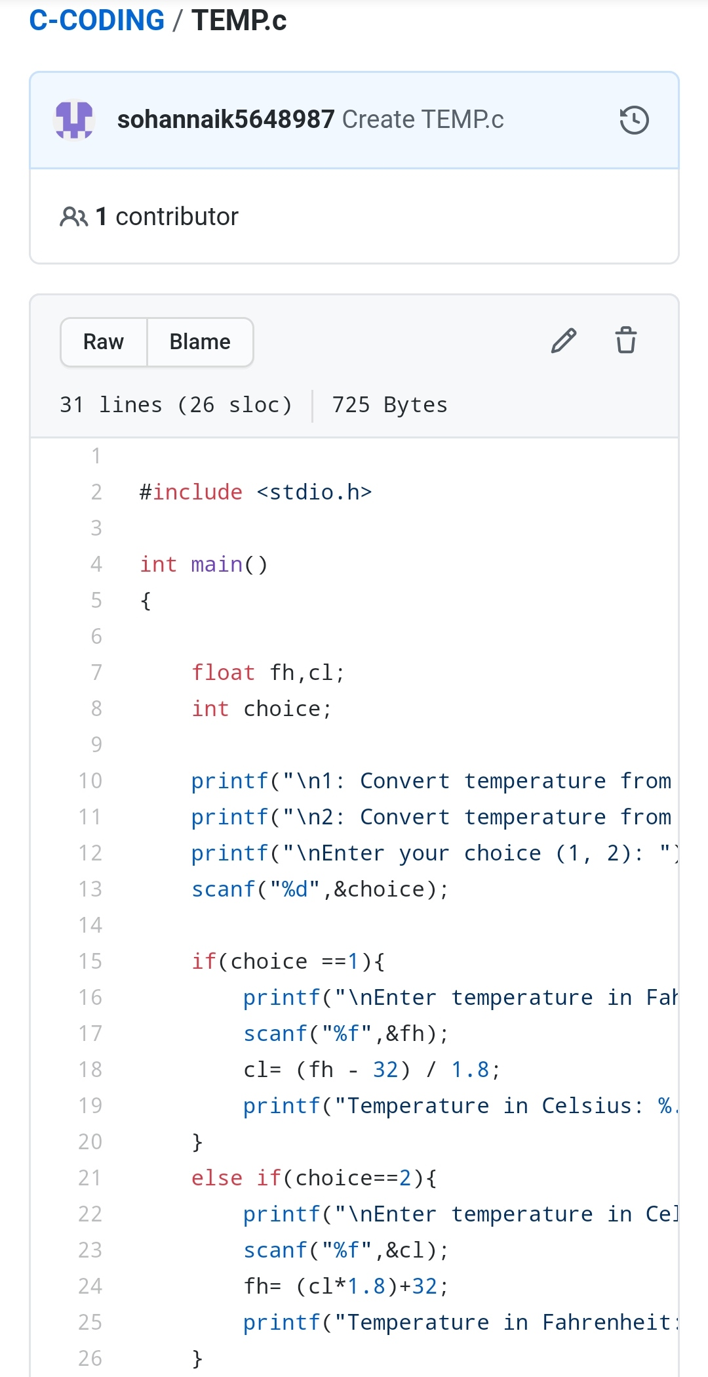

REPOSITORY LINK:https://github.com/sohannaik5648987/C-CODING